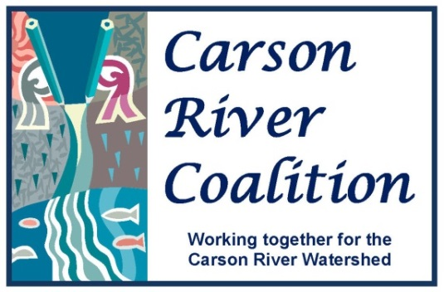

Education Working Group
Wednesday, September 25, 2013
DRAFT Agenda

Time: 8:30 AM – 10:30 AM
Place: CWSD Offices, 777 E. William Street, Suite 110A Carson City, NV
Contact: Linda Conlin 775-230-0633 or Brenda Hunt 775-887-9005

Agenda Items
- Welcome & introductions

- Brief Announcements/Two Minute Updates
  - Harley Davidson Workdays (Revised dates?)
  - DRI Green Box
  - Events (Markleeville Creek Day, Kiwanis Clean-up, Green Living Fest)
  - Children’s Museum Meeting
  - Other

- Snap Shot Day Planning (Mary Kay)
  - Training Day Planning for Oct. 9
  - Calibration Day
    - Set date
    - Any equipment needs?

  - Event Day Oct. 18
    - Site leaders
    - Schools
    - Other logistics (transportation/buses)

- Other

- Set date for next meeting

