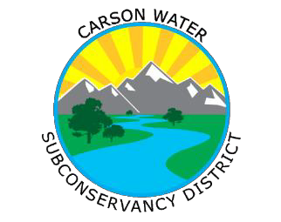
Carson Water Subconservancy District
777 East William Street, Suite 110A Carson City, Nevada 89701
Contact: Catrina Schambra (775)887-7450
www.cwsd.org

November 19, 2020

Carson City, NV – The Carson Water Subconservancy District is now taking nominations for candidates to receive the 2021 Andy Aldax Award as described below:
Award Purpose and Scope
The CWSD Andy Aldax Award for Exemplary Service in Conservation and Protection of the Carson River Watershed was initiated in 2007 to honor Andy Aldax, a Carson Water Subconservancy District (CWSD) Board member since its inception in 1959 - 2013. Andy was a life-long resident, farmer, and dairyman in the Carson Valley of northern Nevada and demonstrated an ongoing dedication to improving his community, as well as the Carson River Watershed. Andy passed on February 25 of this year.
The Carson River runs approximately 184 miles beginning in Alpine County, California and continuing through Douglas County, Carson City, Lyon County, and Churchill County, Nevada. Its watershed encompasses approximately 3,966 square miles. The Carson River Watershed Vision is to achieve healthy sustainable watersheds within the entire Carson River Basin; to achieve improved watershed conditions, so all lands and waterways (surface and underground) safely receive, store, and release clean water for the good of all peoples, environments and natural resources of the Carson River Basin; to achieve this vision through community led and private/public partnerships for implementation of local and basin wide plans and projects.
This award recognizes individuals or organizations for significant contributions in promoting and achieving the Carson River Watershed Vision.

Please submit a 1-page narrative outlining how the nominee meets the award criteria outlined below to Catrina Schambra at catrina@cwsd.org by December 3rd, 2020 (Thursday).

Award Criteria
For the nominee to be considered for this award, they must:
- Have demonstrated a commitment to Carson River Watershed conservation activities for 10 years or more;
- Have produced accomplishments toward the goals outlined in the Carson River Watershed Vision Statement; and
- Be a landowner, community member, or employee of a federal, state, or local entity living or working in the Carson River Watershed.

CWSD will review the list of nominees and present the award at the January 20, 2021 Board Meeting.
###

