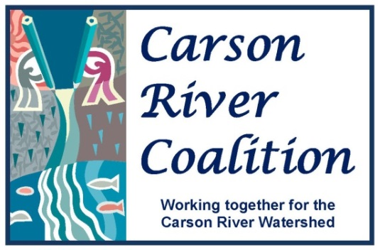

Education Working Group
Wednesday, June 4, 2014
DRAFT Agenda

Time: 1:30 PM – 4:30 PM
Place: CWSD Offices, 777 E. William Street, Suite 110A Carson City, NV
Contact: Linda Conlin 775-230-0633 or Brenda Hunt 775-887-9005

CRC Education Working Group Vision:
A Carson River Watershed community that believes their behavior impacts watershed-wellness and applies their knowledge to act in ways that benefit the Watershed as a whole.

Agenda Items
- Welcome & introductions

- Brief Announcements/Two Minute Updates
  - Update on Invasive Species Month (Courtney)
  - Conserve Carson River Workdays Wrap-up (Linda)
  - Update on the “Get on the Bus” Watershed Tour (Brenda)
  - GREENevada update (Linda/Courtney)
  - Motorized Trail Grant update (Courtney)
  - Carson City Weed Coalition Update (Courtney)
  - Other Upcoming events: Alpine Aspen Festival, Markleeville Creek Day, Carson River Festival, Work day with Comstock Youth Workers, etc.

- Children’s Museum (Watershed Literacy Grant)

- Working Group Exercise: Update the Explore Your Watershed Map for reprinting – We have received 319 funding to update the map and reprint it.

  - Share feedback from teachers on map updates (Mary Kay)
  - Budget, printing and artist costs (Brenda)
  - Review back panels to determine changes, additions, subtractions, etc.

- Set date for next meeting

