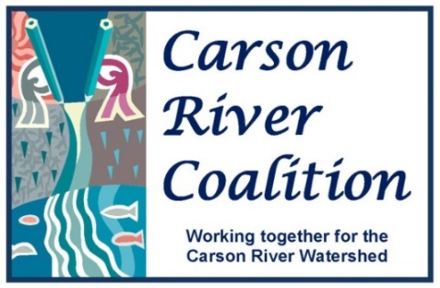

Education Working Group
Thursday, December 10, 2015
Agenda

Time: 9:00-11:00 AM
Place: CWSD Offices, 777 E. William Street, Suite 110A Carson City, NV
Contact: Linda Conlin 775-230-0633 or Brenda Hunt 775-887-9005

CRC Education Working Group Vision:
A Carson River Watershed community that believes their behavior impacts watershed-wellness and applies their knowledge to act in ways that benefit the Watershed as a whole.

Agenda Items

- Welcome & introductions

- Environmental Education Forum Planning Session
  - Set Date
  - Set Venue
  - Set Invitation List
  - Set Agenda for Day Conference
  - Lunch ideas
  - Follow-up process/Survey
  - Other items

- Other

- Set date for next meeting

